Armatage Neighborhood Mini Grants Program and Application Guidelines
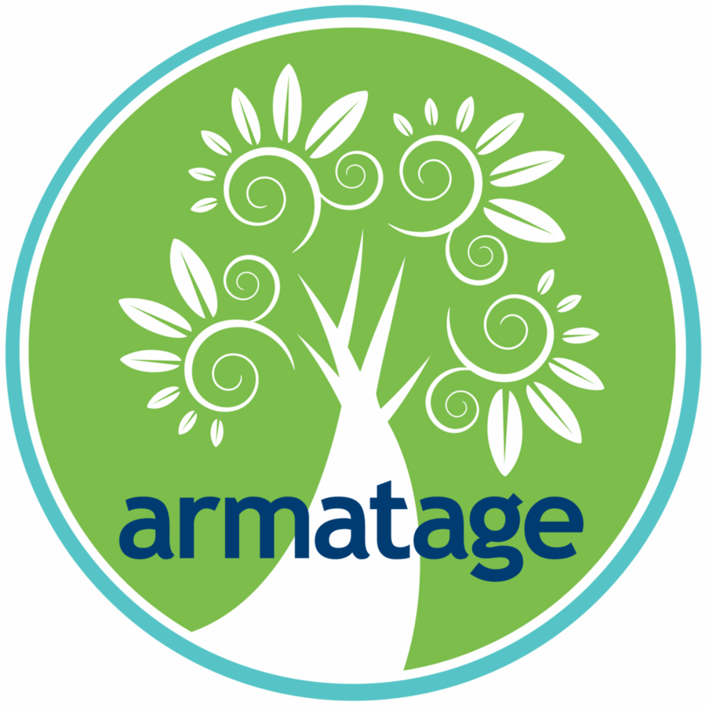
Background: In May 2018, at the Armatage Neighborhood Association (ANA) Annual Meeting, neighbors shared many ideas to engage and enhance our community. As a result, the ANA Board created the Armatage Neighborhood Mini Grants Program to enable residents, businesses, schools, and organizations active in our community to dream up and implement ideas that will benefit our neighborhood.

Do you have an idea? Here is the information on the Mini Grant application and selection process.

WHO can apply: Funding is available to applicants who currently live or operate in Armatage neighborhood (bound by 54th Street to the North; Logan Avenue to the East; Highway 62 to the South; and Xerxes Avenue to the West.) This includes individuals, businesses, schools, nonprofits, and community organizations. Unfortunately we cannot fund religious institutions.

WHAT can be funded: Projects that support, strengthen and/or engage the Armatage community.

WHAT cannot be funded: Planning expenses, operating expenses (emergency funds, budget deficits, fundraising, wages), capital expenses (building improvements, renovations, purchases), religious or partisan political activities, equipment, entertainment, food and beverages.

ABOUT Mini Grants funding:
- Each applicant may submit no more than one grant application per cycle.
- Grants are awarded for projects that best reflect the purpose of the Mini Grants Program and fit the Selection Criteria (see below).
- Grant awards do not exceed $1,000 per project.
- Every cycle, ANA will award up to four grants. In 2019, there will be one grant cycle.
- Grantees have one year from being notified of their award to complete their project and report back to the ANA.

HOW to apply: Download the Armatage Neighborhood Mini Grant Application Form at http://armatage.org/programs/mini-grants/, complete it and submit to anacoordinator@armatage.org or the ANA at 2500 West 57th Street, Minneapolis, MN 55410.

Selection Criteria (not in order of importance): The Review Committee will use these criteria to evaluate each proposal and recommend strongest proposals for Board approval.
- Demonstrated need: Why is funding for this project needed?
- Clear benefit to Armatage neighborhood: What will be the project impact on the neighborhood?
- Innovation: How does this project address a need in a new way?
- Likelihood of success: What is the likelihood that the project will be successfully implemented? Does the applicant have capacity to execute the proposed project?
- Collaborative approach: How does the project engage the Armatage neighborhood?
- Timeframe for implementation: How long will the project take to complete? Can it be sustained over time?

Review Process and Review Timeline:
Proposals will be reviewed once per year by the ANA Mini Grant Review Committee, composed of selected ANA Board and community members who are not affiliated with any of the grants up for consideration. This Committee will evaluate each proposal based on the Selection Criteria (see above) and will make recommendations for approval to the Board. Grant awards will be finalized by Board vote. The Board reserves the right to reject Committee grant award recommendations.

IMPORTANT DATES:
- April 1, 2019: Armatage Neighborhood Mini Grants Application launch
- May 21, 2019: ANA Board hosts a Mini Grants Q&A at the ANA Annual Meeting
- June 15, 2019: Mini Grants Application submission deadline
- August 1, 2019: Mini Grant recipients announced

Questions? If you have any questions or need assistance, contact anacoordinator@armatage.org
Armatage Neighborhood Mini Grants Application Form

The goal of the Armatage Neighborhood Mini Grants program is to support, strengthen, and engage the Armatage Neighborhood community. Grants are available for up to $1,000. Application deadline is June 15, 2019. If you have any questions or need assistance completing the application, contact anacoordinator@armatage.org. Download the grant application at http://armatage.org/programs/mini-grants/, complete it, and email it to anacoordinator@armatage.org or mail it to the ANA at 2500 West 57th Street, Minneapolis, MN 55407. Award notifications will be made by August 1, 2019.
__________________________________________________________________________________________________

Applicant Information

- Individual
- Business
- Community Organization/ Non-profit
- School

- Name:

- If a business, community organization, or school, specify name:

- Website:

- Mission:

- Address/Phone:

- Contact person name and email address:

- Connection to Armatage Neighborhood:

Funding Request
- Amount Requested:

- Project Description:

  - Describe the need that this project aims to address and how it will be addressed :

  - Specify the geographic area of impact:

  - How will members of the Armatage Neighborhood be involved in project implementation?

  - Describe the expected impact:

- Estimated Budget:

  - If partial award is made, how will you supplement the grant funding?

- Timeline for project implementation:

- One-time event
- Recurring

- Evaluation: How will the impact of this project be measured?

- Reporting: Do you agree to send a mid year and final report to the ANA?

