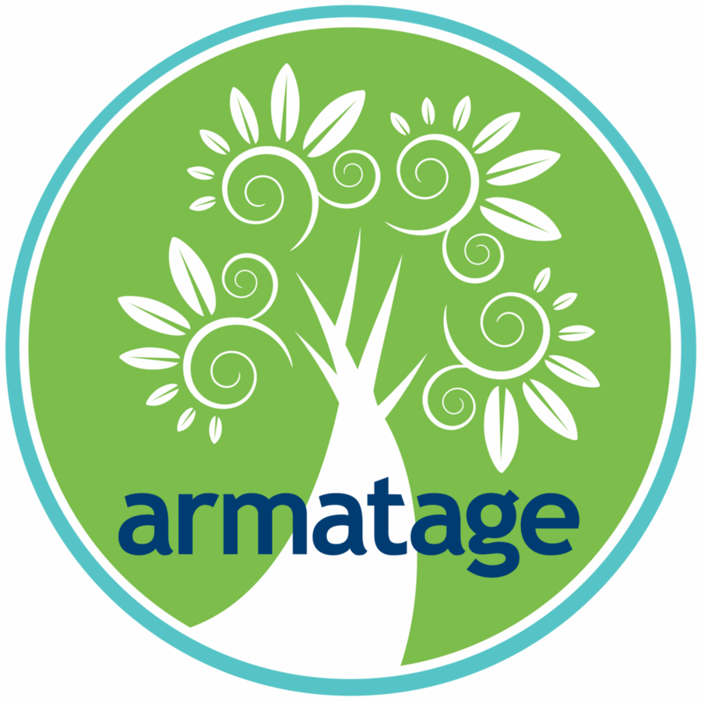
Armatage Neighborhood Mini Grants Program and Application Guidelines

Background: Launched in 2019, Armatage Neighborhood Mini Grants Program to enable residents, businesses, schools, and organizations active in our community to dream up and implement ideas that will benefit our neighborhood.

Do you have an idea? Here is the information on the Mini Grant application and selection process.

WHO can apply: Funding is available to applicants who currently live or operate in Armatage neighborhood (bound by 54th Street; Logan Avenue; Highway 62; and Xerxes Avenue.) This includes individuals, businesses, schools, nonprofits, and community organizations. Unfortunately we cannot fund religious institutions.

WHAT can be funded: Projects that support, strengthen and/or engage the Armatage community.

WHAT cannot be funded: Planning expenses, operating expenses (emergency funds, budget deficits, fundraising, wages), capital expenses (building improvements, renovations, purchases), religious or partisan political activities, entertainment, food and beverages.

ABOUT Mini Grants funding:
- Each applicant may submit no more than one grant application per cycle.
- Grants are awarded for projects that best reflect the purpose of the Mini Grants Program and fit the Selection Criteria (see below).
- Grant awards do not exceed $1,000 per project. Every cycle, ANA will award up to four grants.
- Grantees have one year from being notified of their award to complete their project.
- Grantees are required to attend a short orientation, check in mid-year and report back at the end of the grant cycle.

HOW to apply: Download the Armatage Neighborhood Mini Grant Application Form at armatage.org/mini-grants, complete it and submit to anacoordinator@armatage.org or the ANA (2500 West 57th Street, Minneapolis, MN 55410).

Selection Criteria (not in order of importance): The Review Committee will use these criteria to evaluate each proposal and recommend strongest proposals for Board approval.
- Demonstrated need: Why is funding for this project needed?
- Clear benefit to Armatage neighborhood: What will be the project impact on the neighborhood?
- Innovation: How does this project address a need in a new way?
- Likelihood of success: What is the likelihood that the project will be successfully implemented? Does the applicant have capacity to execute the proposed project?
- Collaborative approach: How does the project engage the Armatage neighborhood?
- Timeframe for implementation: How long will the project take to complete? Can it be sustained over time?

Review Process and Review Timeline:
Proposals will be reviewed once per year by the ANA Mini Grant Review Committee, composed of selected ANA Board and community members who are not affiliated with any of the grants up for consideration. This Committee will evaluate each proposal based on the Selection Criteria (see above) and will make recommendations for approval to the Board. Grant awards will be finalized by Board vote. The Board reserves the right to reject Committee grant award recommendations.

IMPORTANT DATES:
- January 6, 2020: Armatage Neighborhood Mini Grants Application released
- Mini Grants Info Sessions:
  - Thursday, January 30 at 7:00pm at Book Club (5411 Penn Ave S)
  - Tuesday, February 11 at 7:00pm at Armatage Park
- March 7, 2020: Mini Grants Application submission deadline (extended)
- April 22: 2020 Mini Grant recipients announced

Questions? If you have any questions or need assistance, contact anacoordinator@armatage.org
Armatage Neighborhood Mini Grants Application Form

The goal of the Armatage Neighborhood Mini Grants program is to support, strengthen, and engage the Armatage community. Grants are available for up to $1,000. To apply, submit this application by March 7, 2020 to anacoordinator@armatage.org or the ANA (2500 West 57th Street, Minneapolis, MN 55410). Visit armatage.org/mini-grants or contact anacoordinator@armatage.org with questions. Award notifications will be announced April 22, 2020.
__________________________________________________________________________________________________

Applicant Information

- Individual
- Business
- Community Organization/ Non-profit
- School

- Name:

- If a business, community organization, or school, specify name:

- Website:

- Mission:

- Address

- Phone:

- Contact person name and email address:

- Connection to Armatage Neighborhood:

Funding Request

- Amount Requested:

- Project Description:

  - Describe the need that this project aims to address and how it will be addressed:

  - Specify the geographic area of impact:

  - How will you communicate your project to the neighborhood (eNews, social media, website, submission to Armatage News print newsletter)?

  - How will members of the Armatage Neighborhood be involved in the implementation of your project?

  - What volunteers do you anticipate recruiting?

  - Describe the expected impact:

- What assistance do you anticipate needing from the ANA?

- If you need to modify your project, do you agree to contact the ANA for approval prior to making any modifications?

- Estimated Budget:

  - If partial award is made, how will you supplement the grant funding?

- Timeline for project implementation:

- One-time event
- Recurring

- Evaluation: How will the impact of this project be measured?

- Orientation: Do you agree to attend a short orientation in May 2020?

- Reporting: Do you agree to send a mid year and final report to the ANA?

